* Creating directory in desktop then creat 2 file using touch cmd.

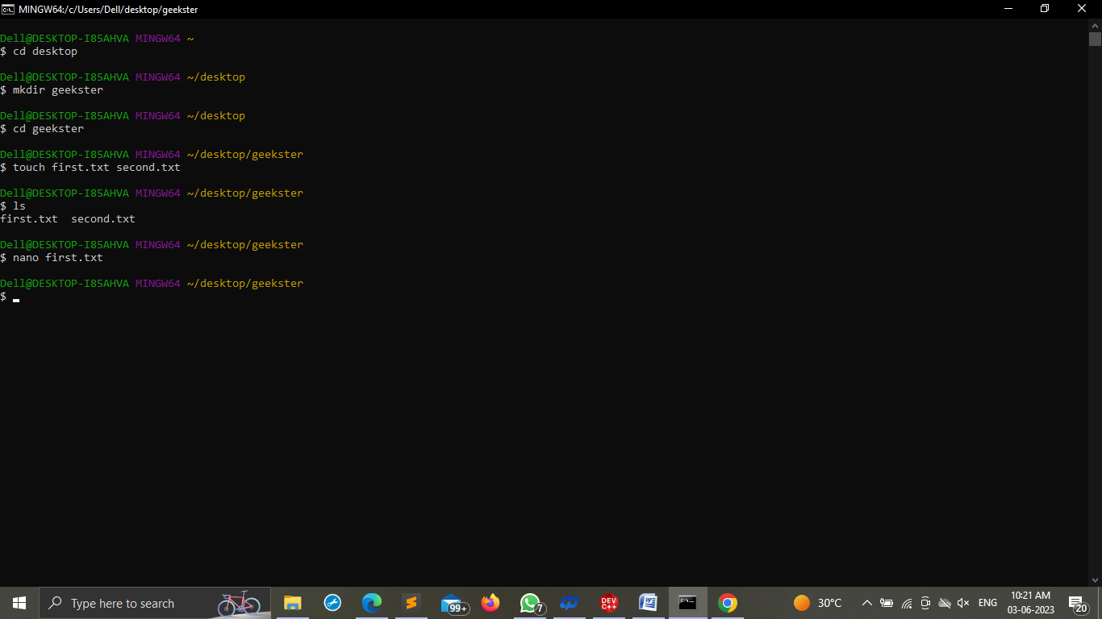

* using nano cmd writing content in first.txt file

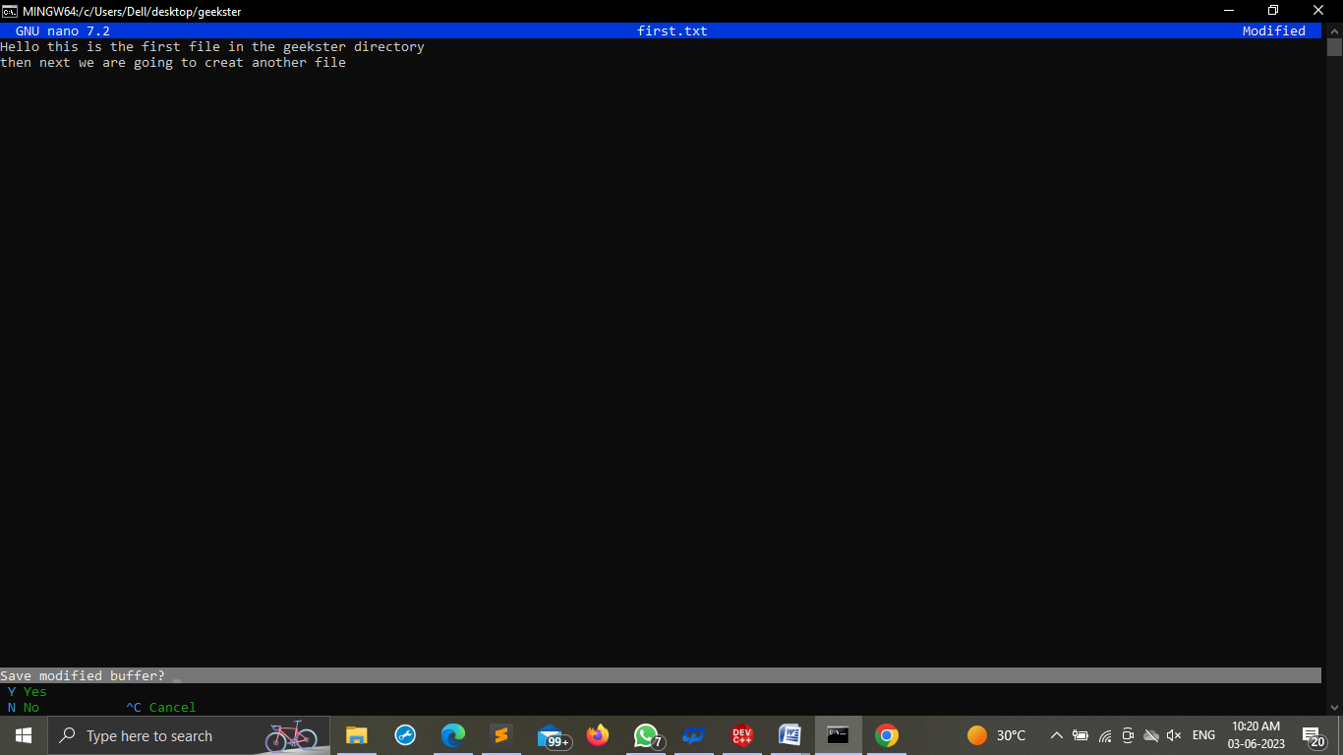

* Display first.txt file content and copy to second.txt file

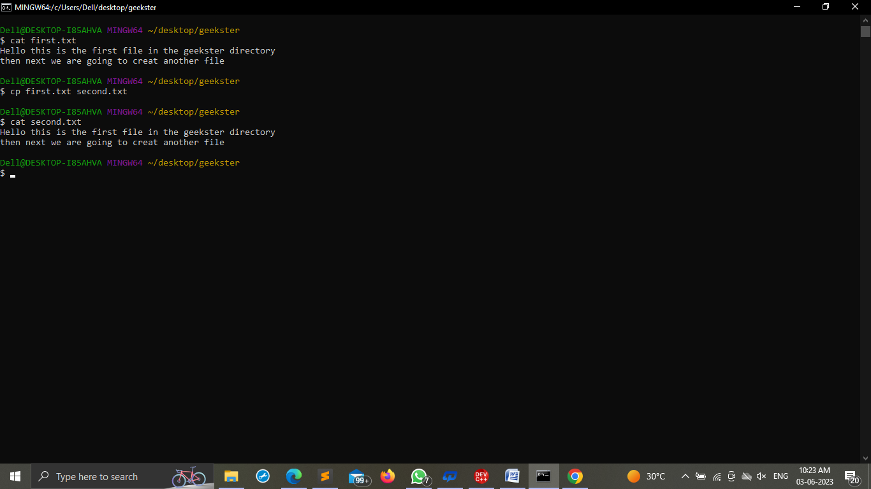

* Checking git verion, Initialize an empty git repository.

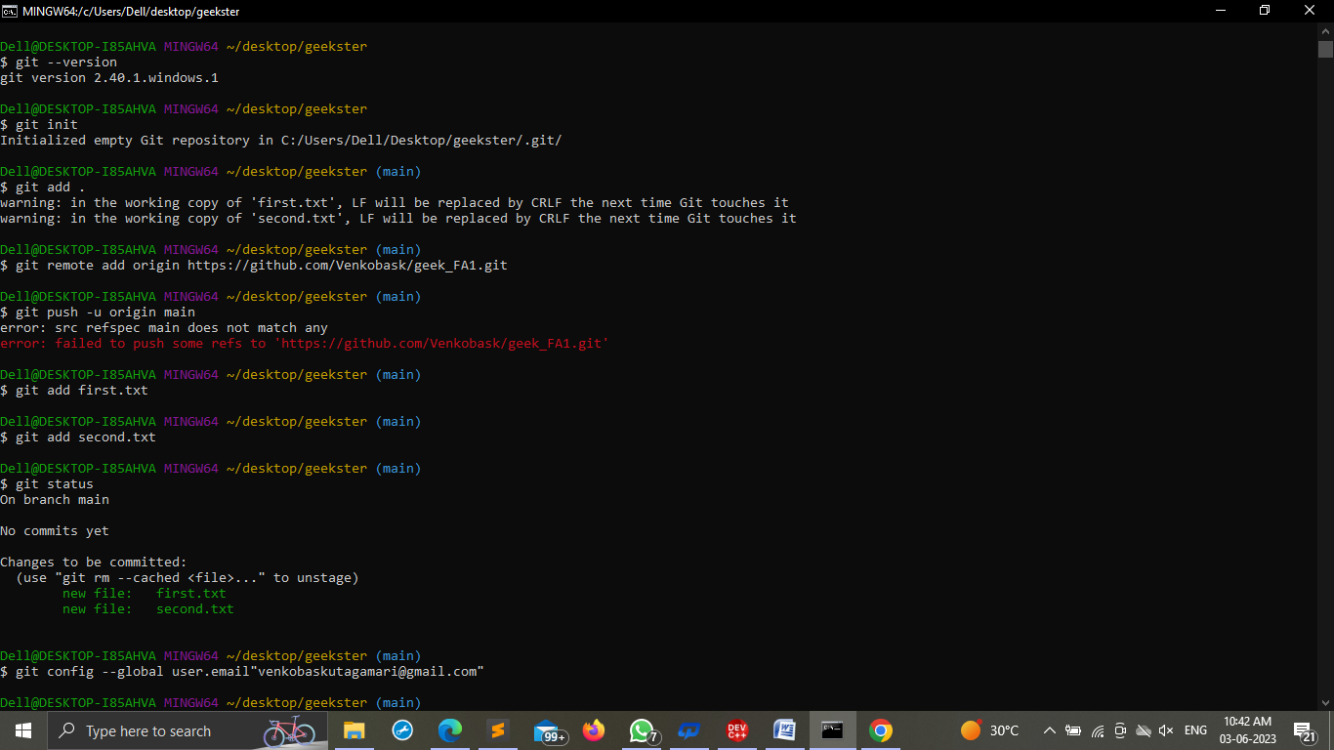

* Commit with the message "adding first.txt".
* Create a github repository with your own name
* Push your code to same repository

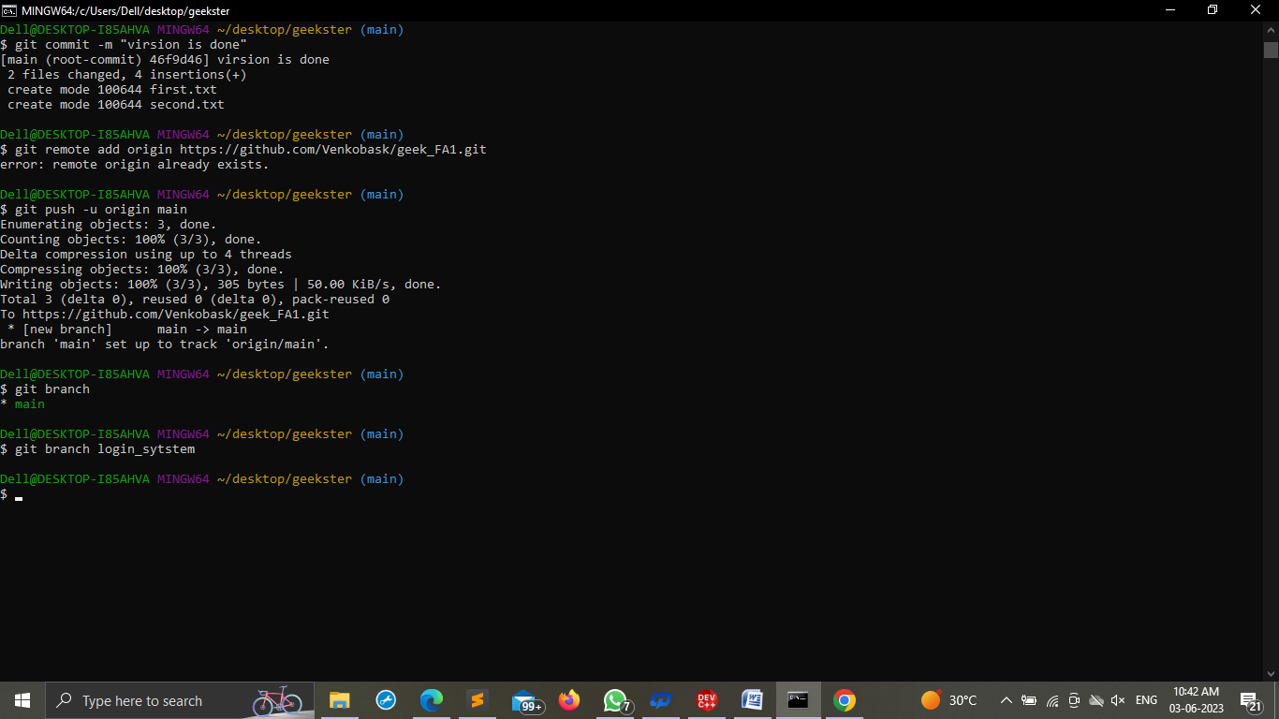

* Check out your commits using git log

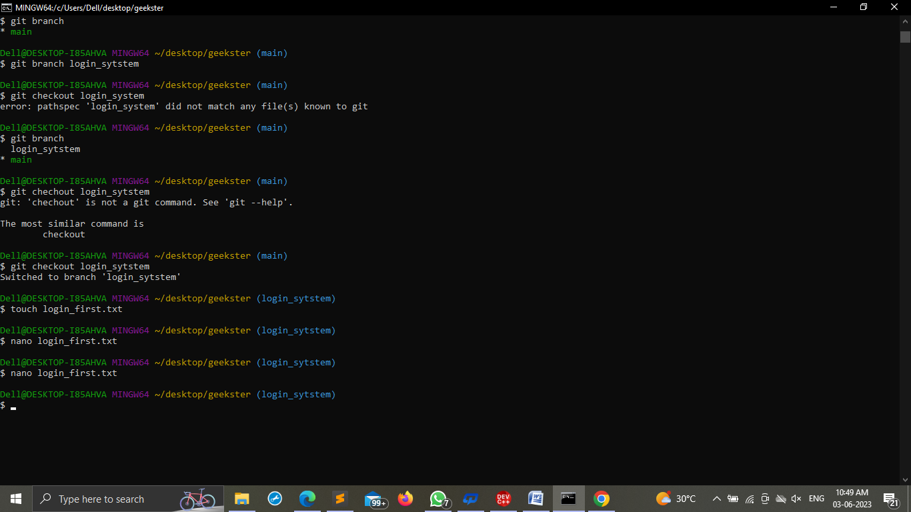

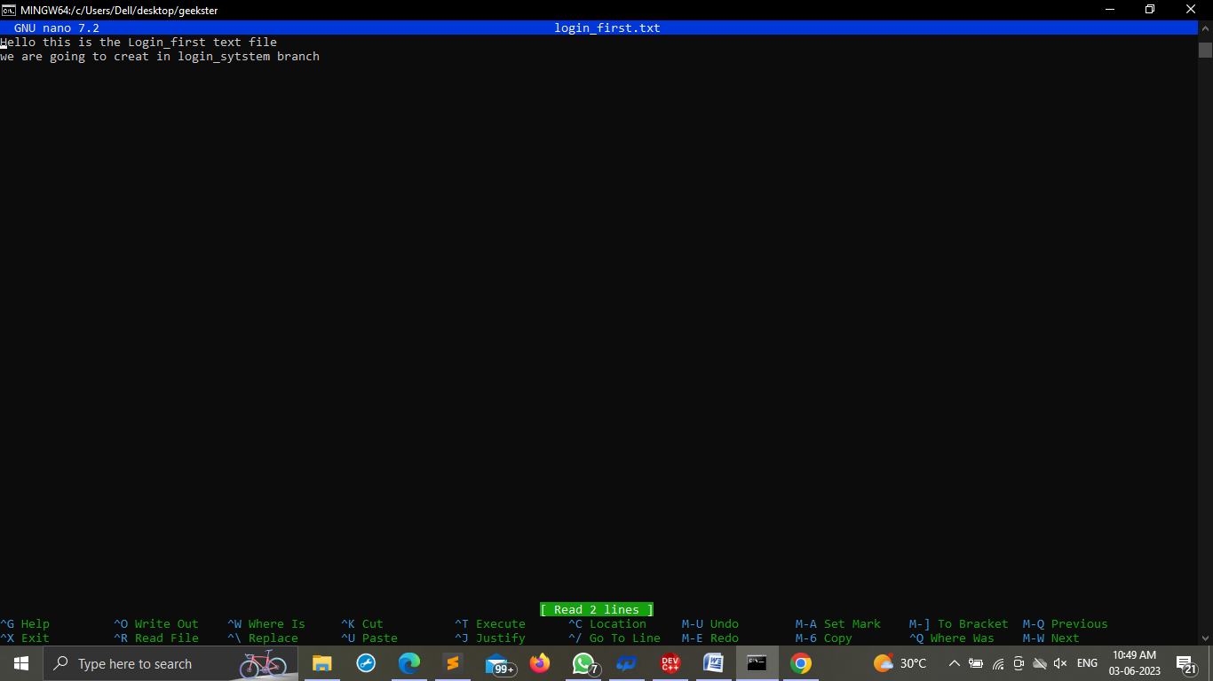

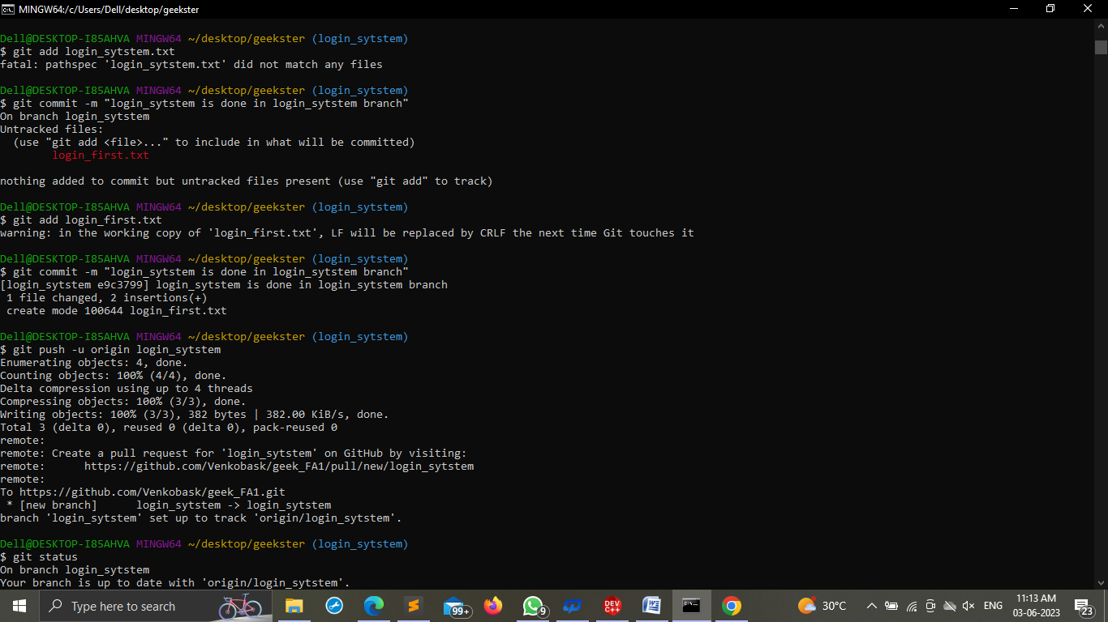

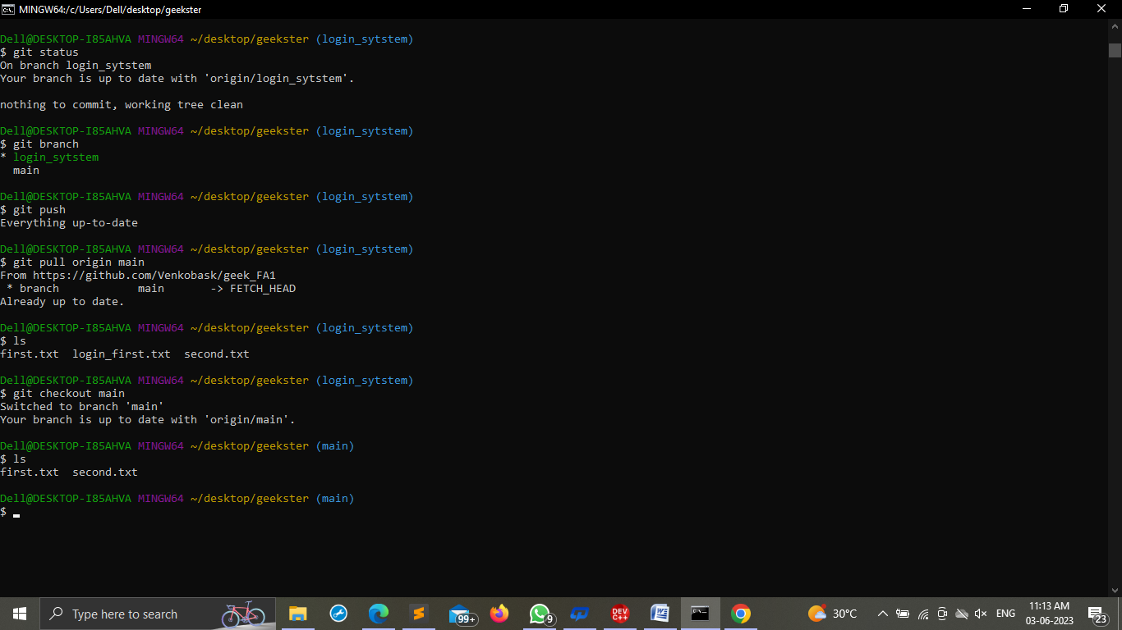

* Host the repository on github pages and attach the link here

Repository link: https://github.com/Venkobask/geek_FA1